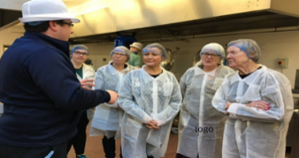

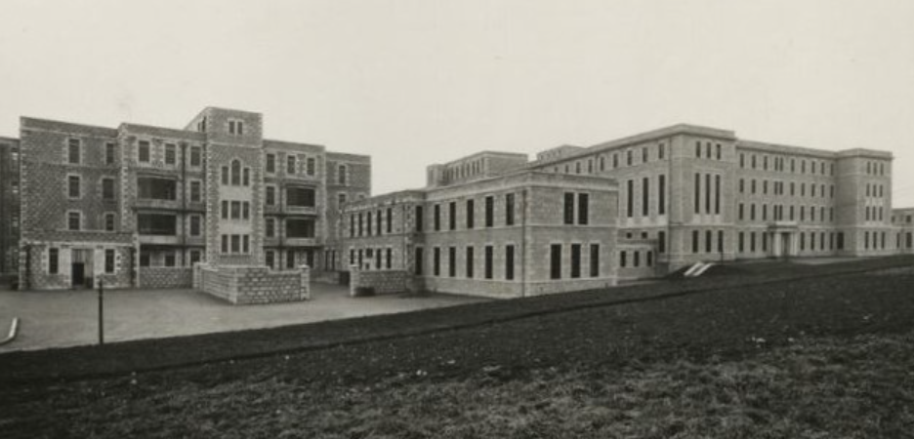



**‘Tomorrows World’**

**Are you interested to learn about ways technology could revolutionise the future of health care services in Grampian**

Join this exploratory webinar from the NHS Grampian innovation Hub to find out how robots could enhance the way patients receive care

How artificial intelligence is already making a difference in surgical treatments and how new technologies are making diagnosis quicker than ever



**History of ARI Walking Tour**

**If you are interested in local history this event is for you. Join the NHS Grampian Archivist who will guide you through the history and development of Foresterhill.**

This enlightening and interactive event will offer participants an introductory presentation

**Followed by**

A guided walking tour to offer additional insight into the history, origins and stories around some of our most iconic buildings



**‘Come Dine with me’**

**The NHS Grampian Catering Manager would like to invite you to join us at ARI for a behind the scenes experience to find out:**

How NHS Grampian serves over 2,000 meals a day

Where NHS Grampian sources the produce which goes into all their meals

**AND**

Be a meal taster and give feedback on a selection of dishes

This lunch time event is sure to change the way you think about hospital food – all dietary requirements are catered for

**Grampian Hospital Art Trust (GHAT) Walking Tours at ARI**

**The GHAT team invites you to join an interactive walking tour of ARI to explore the wide range of local art situated around the hospital.**

This unique walking tour will offer participants:

A creative session with GHAT staff

An opportunity to learn more about the GHAT Collection

**And**

A guided tour of our current exhibitions



:

**‘The Repair Shop’ Sustainability in NHS Grampian**

**The NHS Grampian Sustainability Team invite you to take an inside peek at the work of our laundry team championing ‘make do and mend’ sustainability.**

Get an insight to the work involved in managing linen, towels and gowns for thousands of staff and patients, and the creative approach the team have to sewing and making bespoke items for our patients.





